# How to register App at SharePoint tenant level

Go to the O365 SharePoint admin Portal URL to register a new app:

<https://reisystemsinc257-admin.sharepoint.com/>[_layouts/15/appregnew.aspx](https://reisystemsinc257.sharepoint.com/_layouts/15/appregnew.aspx)

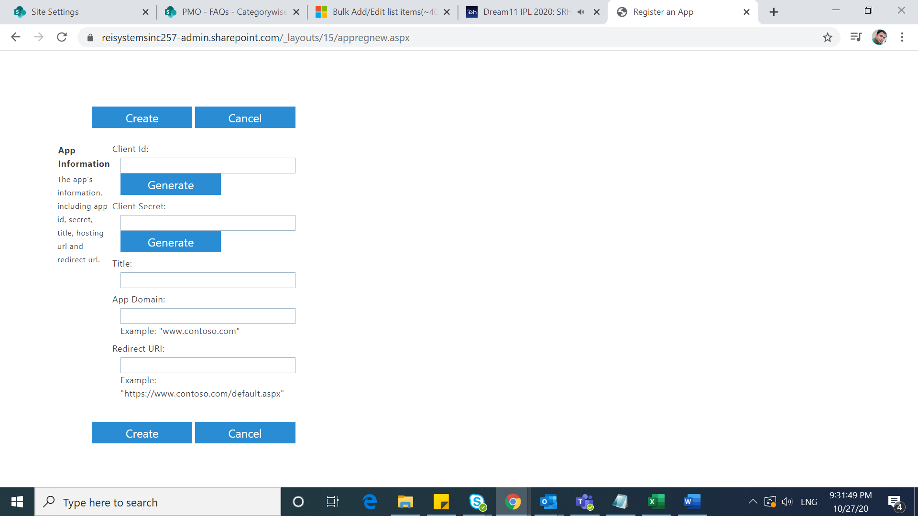

* Generate Client ID and Client Secret and Provide Title and APP Domain (e.g. <http://localhost>) and Redirect URL same as APP Domain.
* Once the Client ID and Secret created at tenant, Go to below link:

<https://reisystemsinc257-admin.sharepoint.com/_layouts/15/appinv.aspx>

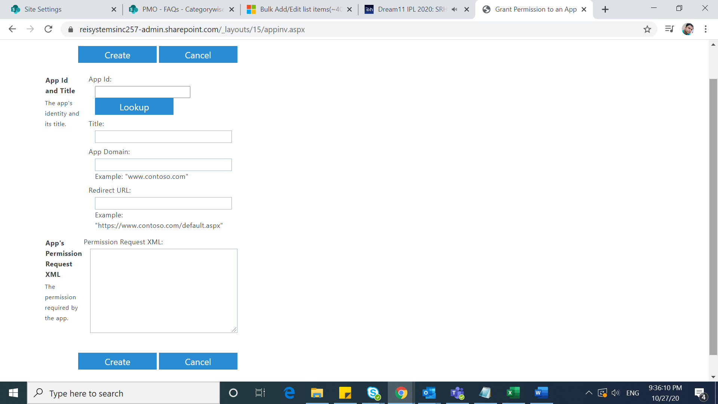

* Provide Client Id under APP ID section and click on Lookup section.
* It will auto generate the details you provided during App creation.
* Provide the below Xml for App permission:

<AppPermissionRequests AllowAppOnlyPolicy="true">

    <AppPermissionRequest Scope="<http://sharepoint/content/tenant>"

     Right="FullControl" />

<AppPermissionRequest Scope="<http://sharepoint/content/sitecollection/web>" Right="FullControl" />

<AppPermissionRequest Scope="<http://sharepoint/content/sitecollection>" Right="FullControl" />

</AppPermissionRequests>

* Click on create and your APP Client ID and Secret is ready to use